# **Visual enhancements for SharePoint**

Contents

Installation 2

Configuration 6

utilities 7

Activating REMARQ 7

enabling a list 8

What to expect 11

Web Parts 12

Reports 12

API 12

licenses **Error! Bookmark not defined.**

LanguageS **Error! Bookmark not defined.**

support 12

FAQs 16

Utilities 18

Quick Start 19

|  |  |
| --- | --- |
| July 2016 | Balsamic Solutions | Proprietary and Confidential | info@balsamicsolutions.com  C:\Users\Robert\Desktop\Remarq PNGs\Remarq-Logo.png  C:\Users\Robert\Desktop\Balsamic-Solutions-logo-separation.png |  |
|  |
| Contents  EA Components3  Installation7  Configuration14  ENABLING EA 27  sharepoint 29  Administration30  Upgrading34  It’s safe to say that Microsoft SharePoint Server™ is one of the most widely deployed technologies for document management and business collaboration. *RemarQ* ™ is an enhancement to SharePoint that provides visual tracking for what you (as a SharePoint user) do on a SharePoint site. *RemarQ* keeps track of all of the things that you read in SharePoint and makes sure you know, at a glance, what you have or have not read. We are all familiar with email, and usually email systems do something similar in our Inbox. Messages that are unread usually are displayed with some type of visual clue (**bold** or *highlighted*) that indicates whether or not you have read it. *RemarQ* does the same thing for SharePoint but with lots of bells and whistles. The first release of *RemarQ* supported Microsoft SharePoint 2013 Foundation and Server editions. This is the Open Source release and also supports SharePoint 2016. |

# Installation

*RemarQ* is a SharePoint solution, so if you are familiar with installing and managing SharePoint solutions you won’t find many surprises here. If you’re not familiar with SharePoint solutions you might want to read up a bit first. You can find some helpful information at <http://technet.microsoft.com/en-us/library/cc263205(v=office.15).aspx> .

## Requirements

RemarQ supports SharePoint 2013 Foundation Edition and Server Edition. It also supports SharePoint 2016. It has been tested with these technologies and has no particular service pack or hotfix requirements.

*RemarQ* stores data in a SQL Server. You can use the same SQL server as the one that your SharePoint uses, or you can deploy it to a different SQL Server altogether. *RemarQ* requires SQL Server 2008 R2 or higher, and it supports all editions of SQL Server including Express.

The only caveat to these requirements is that you must use the new SharePoint look and feel. No support is provided for SharePoint sites that use the 2010 look and feel on SharePoint 2013.

## Licensing

*RemarQ* is a now free and open source, most of the features of the previous Enterprise license are included.

## Downloading

The most current version of *RemarQ* can always be downloaded from our project site on CodePlex. If for some reason you need a previous release, please contact support at [support@balsmicsolutions.com](mailto:support@balsmicsolutions.com) . The distribution download be a compressed file which will include an MSI installer named RemarQ.msi and the most current version of this document. Of course since RemarQ is now open source, you can also download the source code from CodePlex.

## Install RemarQ

The downloaded installer will install the solution file and a few supporting batch files, but it will **not** install the solution into SharePoint. If you have a previous version of *RemarQ* installed, then it will be upgraded automatically during the installation. The installer should be run on a server that is an active member of the SharePoint farm and that hosts the SharePoint Central Administration site. As there are several legitimate repackaging scenarios that don’t require SharePoint, the installer **does not** check this before running. The *Utilities.exe* application only works if it is installed on the SharePoint Central Administration host. After executing the installer, you will find several files in the installation directory (usually *C:\Program Files\Balsamic Solutions\RemarQ*) the most important ones are:

* **AddSolution.ps1**: This is a PowerShell script to install the solution in a SharePoint farm.
* **UpdateSolution.ps1**: This is a PowerShell script that updates the solution on a farm with *RemarQ* already installed
* **BalsamicSolutions.ReadUnreadSiteColumn.wsp:** This is the SharePoint solution file that contains RemarQ and other necessary components.
* **PurgeLocalSPCacheFiles.cmd** : This is a batch file that will stop all of the SharePoint services, purge any local cached configuration objects or precompiled web pages and then restart SharePoint services. You should not need this file unless someone from Balsamic support tells you to run it.
* **Utilities.exe** : This is a console executable that provides some tools for enablement and disablement of entire web sites as well as a managed upgrade processor.
* **RemarQListProcessor.exe**: This is a windows service that can be configured to handle list initialization. Configuration of this service should not be attempted without directions from *RemarQ* support.
* **RemarQAPIVersionOne.pdf**: A reference for using the RemarQ application programming interface
* **RemarQ Administration and Installation**.**pdf**: This is the most current version of the document you are reading now.

## Install and deploy the solution

If you have a custom solution management technology for SharePoint, you should use it now to install the *BalsamicSolutions.ReadUnreadSiteColumn.wsp* file, otherwise open an administrative command prompt in the RemarQ install directory and execute the *AddSolution.ps1* PowerShell file. This will upload the *RemarQ* technology to your SharePoint farm and then deploy it. If you are upgrading an existing implementation, **don’t** use the *AddSolution.ps1* script, instead use the *UPdateSolution.ps1* script.

The administrative features of the solution will be automatically activated in the SharePoint central administration site and should not be deactivated unless you are uninstalling or have been told to deactivate them by someone from Balsamic support.

If you are not familiar with managing SharePoint via PowerShell, you can find an excellent reference here <http://technet.microsoft.com/en-us/library/ee806878(v=office.15).aspx> .

## Configure storage

Now it’s time to stop and talk about storage. *RemarQ* needs access to a Microsoft SQL database to store the data related to read marks and processing rules and other instructions. *RemarQ* needs its **own** database. You must **NOT** configure the system to use a SharePoint database for storage. The database will have a lot of entries in it, all of it related to which lists are configured, how they are configured, who has read what, and other data relevant to *RemarQ*. The database has the same connectivity requirements as a SharePoint content database in that it must be accessible from every SharePoint server. It’s perfectly reasonable to install this database on the same SQL server that hosts your SharePoint databases, but as mentioned before, don’t share an actual database between SharePoint and *RemarQ*. For most uses the RemarQ database should use the *Simple* recovery model, but you should also remember that it needs to be backed up with the same schedule as your SharePoint system.

When you configure the connection between your SharePoint farm and the database, you will have two security options. You can use integrated security, or you can provide a SQL user account. For performance and security reasons we recommend that you use a SQL user account. If you use a SQL user account, you must grant it *dbo* (database owner) access to the database you are using for RemarQ (if you don’t know what that means your DBA does. If you don’t have a DBA, then here are a few YouTube references that can help you get through it.

* Create a database <http://www.youtube.com/watch?v=18wZWdMSb9c>
* Create a user <http://www.youtube.com/watch?v=18wZWdMSb9c>
* Grant DBO <http://www.youtube.com/watch?v=18wZWdMSb9c>

If you are going to use integrated security, then all of your SharePoint application pools must be using domain user accounts, and all of those accounts must be granted *dbo* access to the database you are using for *RemarQ*. If you don’t know what that means, you may need some help configuring your system. Send us an email at [info@balsamicsolutions.com](mailto:info@balsamicsolutions.com) describing your SharePoint environment and we will send you some pointers.

By the time you have the database sorted out, it’s very likely that your deployment is finished. You do have to wait until the solution deployment from the previous step is done before continuing.

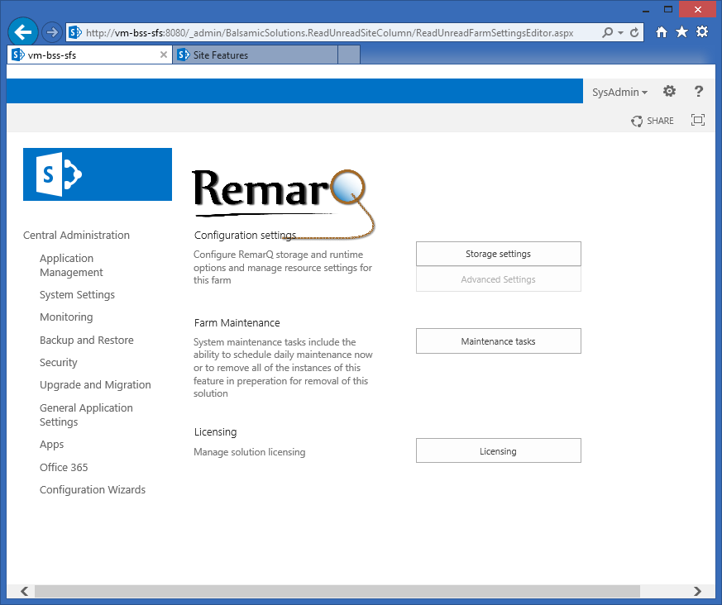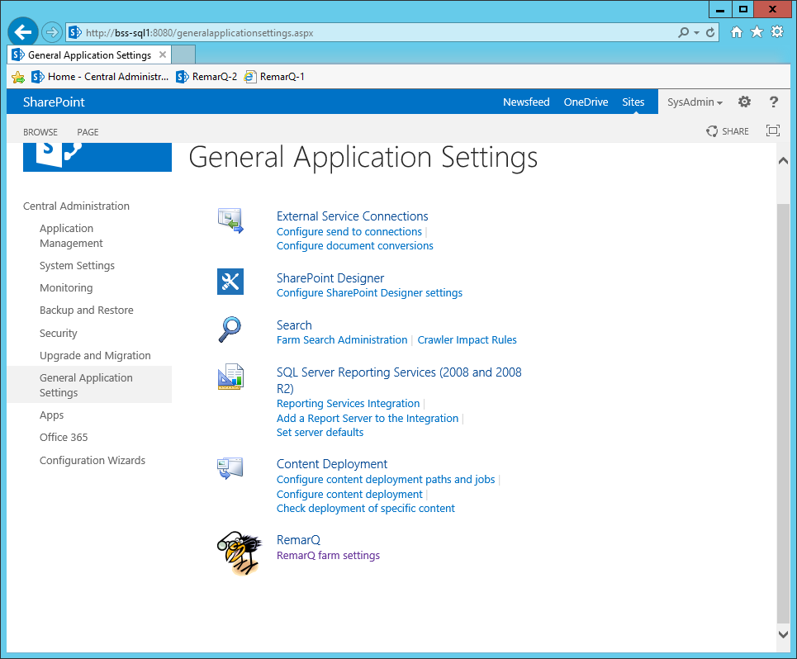Open a browser to your SharePoint Central Admin web site and navigate to *General Application Settings*. You should see a new menu option named RemarQ with a link to *RemarQ farm settings*.

Select the link and you will see the central configuration for RemarQ. This is where you will do all of your RemarQ configuration and management.

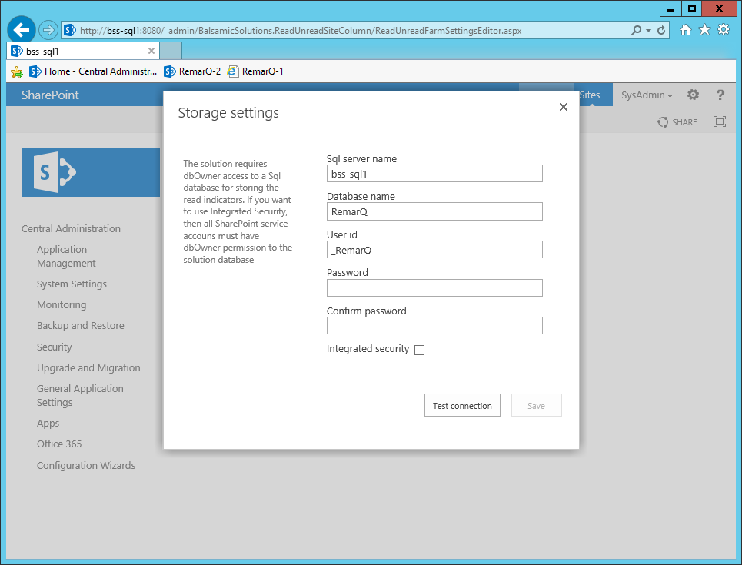

Click on storage settings and you will see a screen similar to this one

Fill in the requested information for:

* **Sql server name**: This is the network name of your Sql server where you created your RemarQ database
* **Database name**: This is the database name of your RemarQ database
* **User id**: This is the SQL user id you created for your RemarQ database. If you are using integrated security, leave it blank.
* **Password**: This is the password for the SQL user id you created for your RemarQ database. If you are using integrated security, leave it blank.
* **Confirm password**: Same as password above.
* **Integrated security**: If you are using integrated security, check this check box; otherwise leave it unchecked.

After you fill in all the user and database information click the test button. If the test is successful you will be allowed to save the information with the save button. If it is not successfully the form will display hints as to what is wrong. You must complete this step successfully before continuing.

**Note for SharePoint gurus**: While we would not normally recommend the use of a Sql user id and password combination, the performance benefit of using this compared to the need to swap out impersonation tokens for every Sql call is enormous. Because of this we have encrypted the storage of the password and recommend the use of Sql user id and a password. The database only stores RemarQ data so there is minimal security exposure. Please do **not** use an SA account or an account you use for any other purpose.

## WAIT 10 minutes

Now comes the hard part. You need to wait until all the servers in your SharePoint farm have received the configuration update. If you only have one server, you are already done. In general it takes about 1 minute per server to push all the changes out to SharePoint servers. Just to make sure, take a minute to have a cup of coffee, or perhaps check out what’s happening on your favorite internet feed.

**Remember this**! Whenever you make a change to a RemarQ central administration setting, it may take a few minutes before the rest of the system sees the change.

Once this happens you can skip to Activating the Feature for a site, or read the next few sections for how to configure advanced options administer the system.

# Configuration

If you check the administration site, you will see an *Advanced Settings* button on the *RemarQ Farm Settings* page.

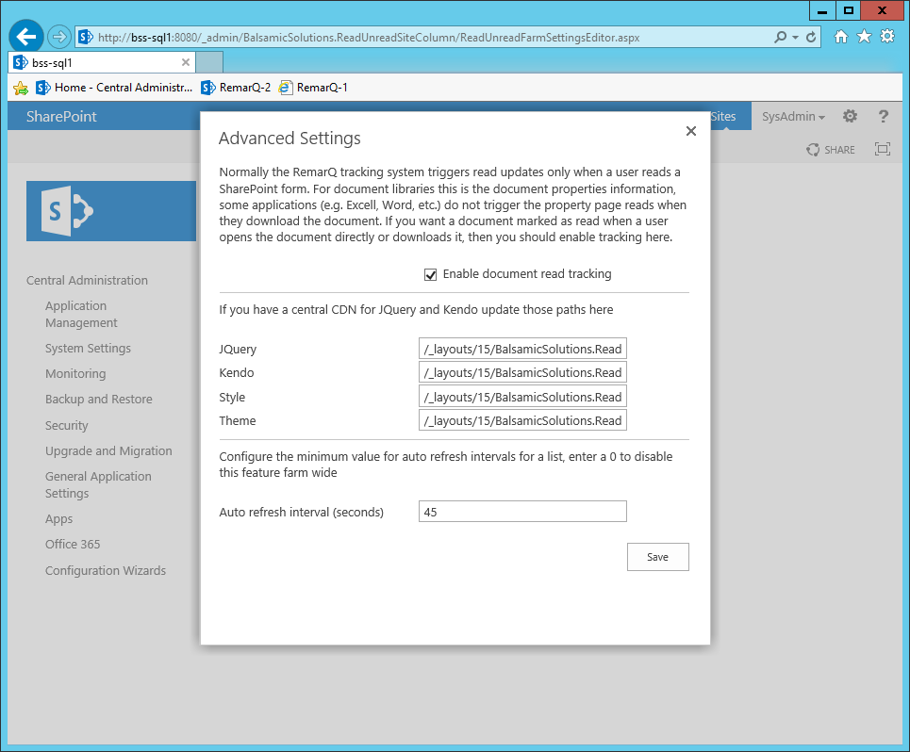

These settings provide access to additional features of RemarQ. The most popular feature is the automatic enablement of document read tracking (*Enable document read tracking*). This feature installs a light weight SharePoint http module into the SharePoint front end web servers that tracks document usage from Office clients. If all of your usage is strictly from web browsers, you don’t need it. If you have users who open content directly from Word or Excel, then you should turn this feature on.

The other advanced settings include:

* **JQuery**: This is the JQuery source file RemarQ uses for some of the markup. If you have an internal CDN capable of delivering JQuery, then enter the URL here. This will speed up some page processing. The minimum version is 1.91, but RemarQ is also tested with the most current 2.X releases.
* **Kendo**: RemarQ also uses the Kendo tool kit (<http://www.telerik.com/kendo-ui>) for some of the administrative pages. The default kendo tool is the open source version of the Kendo UI known as Kendo Core. If you have an internal CDN capable of delivering Kendo UI, then enter the URL for the *kendo.all.min.js* file here.
* **Style and Theme**: These are also Kendo files. If you provided a Kendo URL, then you know what you should enter here.
* **Auto Refresh interval**: In Professional and Enterprise editions, it is possible for a list administrator to enable *Auto Refresh.* When enabled, the browser client will poll for RemarQ updates on a timed interval. The setting here is the minimum value to allow a list administrator to set. If you are concerned with server load, then set it to a higher number (60 or 120). If you need client updates to be more frequent (for example if they are monitoring a support discussion board), then set the value to a lower number. Remember the list administrator cannot make a setting that operates any faster than what you put here. If you want to disable refreshes for the entire farm, enter a 0.

# Maintenance utilities

The maintenance utilities menu is a corrective action menu for administrators that like to monkey with the system. If you are one of those administrators (and you know who you are), these buttons are for you. The utility menu provides four options:

* **Reset maintenance jobs**: Reset the *List Initialization* and *Daily Maintenance* jobs to their default values. These jobs run on a timer and provide critical functionality for RemarQ processing.
* **Run the daily maintenance job now**: Start a *Daily Maintenance* pass now. This will fix menus, event registrations, and broken links (which don’t get broken in normal circumstances).
* **Reset language resource**: This reloads the default English prompts into the system. It does not change or update other language prompts (you must use the culture manager described here for that)
* **RemarQ remove everything**: If you just don’t like RemarQ or have been told that you should not deploy it, this will start a job that will remove all of the fields and control objects from your farm. If you click this, wait until the RemarQ Remove Everything job is complete before removing the solution.

# Activating feature for site

For a specific site collection to leverage RemarQ, it must be activated at the site collection level. RemarQ is a SharePoint feature, so you activate it from the SharePoint *Site Settings* / *Manage site features* menu.

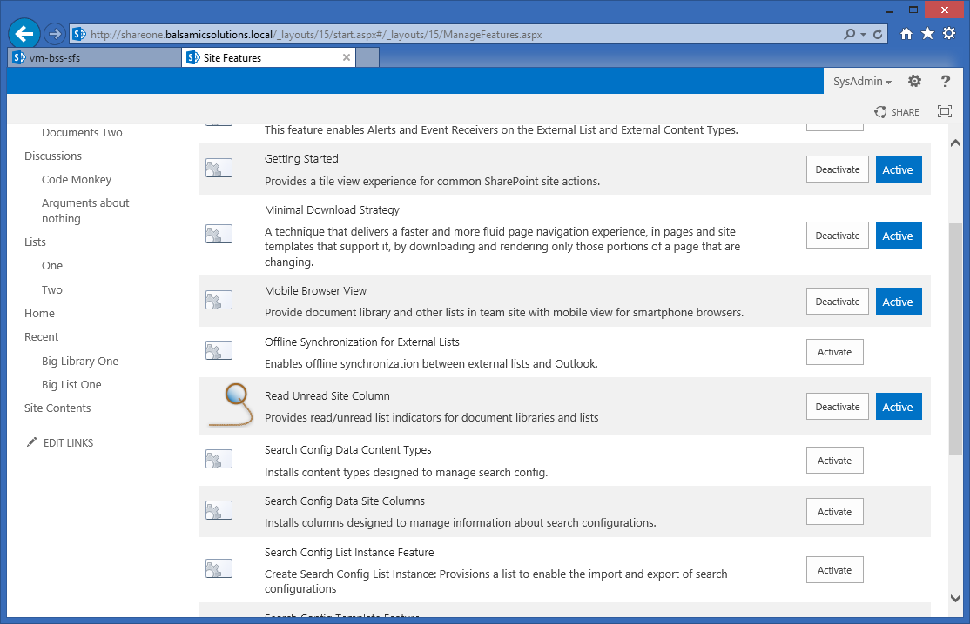Just click on the nifty RemarQ icon (the cute little bird with glasses). If it does not activate, you probably did something wrong. Most likely you did not wait long enough, so read this again.

# 

# 

# Activating the site column for a list

Finally, it’s time to turn on RemarQ and enjoy this fabulous enhancement for SharePoint. (In all reality a reasonably skilled SharePoint administrator should get to this step in about 10 minutes. 20 minutes for a large farm. If you’re having a problem, send us questions at [support@balsamicsolutions.com](mailto:support@balsamicsolutions.com). we are happy to help). ***Remember*** every site collection that you want to provide RemarQ for, must be individually activated.

## RemarQ indicators

To activate RemarQ for a document library, it’s as simple as adding a RemarQ site column to the document library and making sure that RemarQ is displayed in the views that you want to support RemarQ indicators. Most of the administrative tasks associated with a library or list follow this same pattern. To add the RemarQ field from the *Balsamic Solutions* site columns, follow these steps:

* If the library is not already open, click its name on the *Quick Launch*. If the name of the library does not appear in *Quick Launch*, click Site *Contents*, and then click the name of your list or library.
* In the ribbon, click the List or Library tab
* In the Settings group, click List Settings or Library Settings

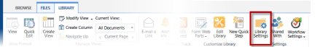

* On the Settings page, in the Columns section, click *Add* from existing site columns
* On the Add Columns from Site Columns page, in the Select Columns section, select “Balsamic Solutions” site columns to choose RemarQ in the Select site columns from drop-down list.

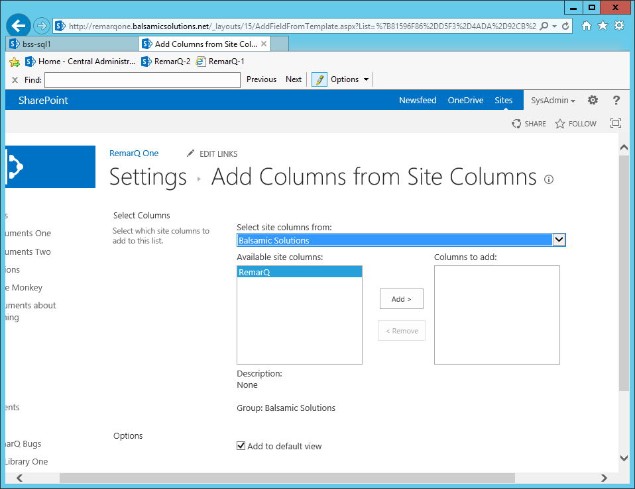

Make sure you have selected *Add to default view*, and then click Ok.

This will initialize the document library with RemarQ settings, the list is not quite ready yet. The list initialization process must be completed by the system before it is ready to work. Depending on how busy the system is, how many items are in the library, and how many lists just got enabled, it might take a minute or much longer. By way of example, a library that has 10 documents in it on a single server SharePoint farm will likely be initialized before you can hit the back button. But a library with 100,000 documents in it will take 25 minutes or more to initialize (yes we tested the system with libraries with 1,000,000 documents in them). So it all depends. The good news is that you will see a status icon immediately. While a list is initializing you will see a working indicator for every document in the library. Go ahead, look and see. It’s a small spinning GIF (the same one that SharePoint uses) next to every document in the library. As the library is initialized, those indicators change to RemarQ highlights.

If all you want is a dark bold highlight, you are done configuring this library. If you want to tweak it a bit, well you can do that too. You access the library specific settings menu by selecting the RemarQ column in the *Columns* section of the settings for the library that you just RemarQ enabled. Depending on your license, you will see options to show highlights or icons. If you select *Show Icons for read or unread*, then the library display will include graphic markers instead of being highlighted.

## 

There are also some *Advanced Settings* available Selecting that button will display the advanced settings for the library. This screen is common across most of the different supported list and library types. The configuration screen will only let you edit values that are appropriate for the list or library and that are available to your license. The options include:

* **Show editing tools on context menu**: If you want to let users mark things as having been read, without actually reading them, then you can enable this context menu. The menu will show up in the **…** menu available for all SharePoint content. This is similar in concept to tools that “Mark all as read” in your email inbox.
* **Show reporting menu**: If you have an Enterprise license, you can activate reporting for items in this library by enabling this option. The user would then select *Readers Report* from the context menu, and they would see a report that displays the read history for a document (or a list item in a list).
* **Clear only on version change**: Normally a document’s read history is reset whenever it is updated. If you have SharePoint version tracking enabled for this library, then you can also tell RemarQ to only reset the read marks when a new version is checked in. This makes it easier for users to monitor libraries where project documents use version tracking.
* **Unread image url**: If you selected *Show Icons for read or unread* you may specify a custom image icon to use for unread documents here.
* **Read image url**: If you selected *Show Icons for read or unread* you may specify a custom image icon to use for read documents here.
* **Auto refresh interval**: If you enabled auto refresh in the RemarQ central admin site, then you can configure a value here to trigger page refreshes. You can enter a value lower than the minimum set in the RemarQ central admin site, the system will adjust this at runtime to the correct value. Enter a value of 0 to disable auto refresh.
* **Unread color**: If you selected *Unread columns are highlighted*, then you may specify a custom color for unread documents here.

Wow, that’s a lot of customization, but it’s also lots of useful tweaking for different types of lists. For example, if you have a library which receives emergency posts from email, you can make them bold **RED** with a frequent auto refresh interval. Your users will love you for it.

Right below the *Advanced Settings* button is a *Utilities* button. These are a few tools for forcing the system to rescan the list without having to reconfigure it. Why would you need this? Well let’s say you had a server crash (I know SharePoint never does that, but other things you run on it might cause aberrant behavior). When this happens, you may get a “broken” C:\Robert-SVN\BalsamicSolutions.ReadUnreadSiteColumn\BalsamicSolutions.ReadUnreadSiteColumn\Images\BalsamicSolutions.ReadUnreadSiteColumn\clscError32.gif link on some of the documents in the library. You will know it when you see it. It calls attention to itself. If you see this, the first thing to do is run daily maintenance. You can wait for it to run automatically, or you can run it manually (remember what we talked about here). Or if you just want to run the process for this list, then select the utilities menu and choose one of these:

* **Re-initialize list**: this deletes all existing indicators and reinitializes this list from scratch
* **Check list**: this performs a non-destructive check of the list. No existing indicators will be lost

Don’t worry. Regular users of the library can’t activate these utilities.

If you have the Professional or Enterprise edition, then RemarQ will also support Discussion Boards, Announcements, and Custom Lists. You enable RemarQ for them the exact same way as for a Document library, with the following subtle (or perhaps not so subtle) differences:

* **Discussion boards**: Discussion boards only support highlighting. Since there is no context menu, the discussion board “mark read/unread” context menu item is replaced with a “toggle” button that turns the indicators off if they are on, and on if they are off. Reporting is not available for discussion board lists and version settings have no impact on operations.
* **Other supported list types**: All of the settings apply to other supported lists type except version settings, which have no impact on operations.

With most lists and libraries, the RemarQ column must be in the current users view to be active. The only exception to this is the *Threaded* view of a discussion board. This means that even if the RemarQ column is on the list, the indicators are not visible unless they are in the view. They are however, always processed. So a user can remove the RemarQ column for their personal view, but that only impacts their visibility of the indicators, not the processing of them.

# What to expect

When everything is configured, what should you see? When an item is considered Read? Why is there air? Well, in its default configuration a user can expect to see *RemarQ* indications in an obvious and intuitive display.

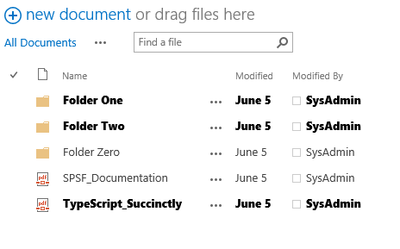

Duh, that is what it’s all about after all. Making it easy to identify what you have already read or have not already read.

An item (document or list item) is considered read when you have read the form (an item) or downloaded the document, or when you intentionally mark the item read using the context menu.

An item is considered unread when you have not done one of those actions or, if you have, then when the item has been updated by a user other than yourself. This simple concept is now fully supported by SharePoint. Folders and discussion threads are rather interesting, what happens if you have read all the documents in the HR folder, and then someone updates the HR policy document in a distant sub folder? In that case, all of the folders that lead to the unread document will become “unread” for you. So you can follow the folder trail down to the item that you need to re-read. Similarly, discussion threads are “thread specific” and act just like folders. When a new reply comes in, the root thread (the Subject in SharePoint nomenclature) is marked as unread so you can easily identify which on discussion board you need to focus.

# Web Parts

There are many times when SharePoint users add “web parts” to a page, when the “Web part” is actually a library or a list. This is a very useful aggregation tool and is fully supported by RemarQ. The only caveat to it is that the RemarQ column must be in the view used by the web part. Unfortunately that’s not a default setting we can control. So if you want RemarQ in the “web part” view of a list, remember to edit the view to use an existing view with RemarQ in it, or to edit the “current view” of the web part so that it included the RemarQ column.

# Reports

Document owners have access to a *Readers Report* for every document or item in a RemarQ enabled list. The report is available to list owners and to document authors. Just click on the *Readers Report* in the context menu and the report will be generated and shown. If Version control is enabled, each of the document’s update sequences will be displayed with separate version dates. This allows you to differentiate read indicators for each user is associated with each version of each document. If you have lots of readers you can also search and sort the *Readers Report* to help you find any specific information you are hunting for.

# API access for workflow integration

There is also a simple API that lets you access the RemarQ data service programmatically. Why would you do that? Well think of a Workflow that actually triggered based on a user reading a document!

# How to get support

Support for *RemarQ* is via email ([support@balsamicsolutions.com](mailto:support@balsamicsolutions.com)) or via special arrangements which we can discuss with you through [info@balsamicsolutions.com](mailto:info@balsamicsolutions.com).

# Random information (aka FAQs)

There are several system status indicators that may show up in a RemarQ enabled list, they are listed below:

* : If you see this on a list item RemarQ is broken (for that item), daily maintenance may fix it, or it may be necessary to reinitialize the list.



* : If you see this on a list item, then someone added RemarQ to an unsupported list type.



* : If you see this on a list item, then the configuration of the list or the system is incorrect.



* C:\Robert-SVN\BalsamicSolutions.ReadUnreadSiteColumn\BalsamicSolutions.ReadUnreadSiteColumn\Images\BalsamicSolutions.ReadUnreadSiteColumn\clscLoading.gif : If you see a small circle of rotating dots, then the list is currently initializing.
* : This image is the “toggle” button we mentioned earlier when we talked about Discussion board configuration.

In answer to the question “Why is there air?” which we asked here. We quote Bill Cosby, “air is for blowing up basketballs”, we agree.

Discussion board displays may feel odd, especially in the *Flat* view, this is because there are no visual clues for the user to distinguish the parent/child relationships of a discussion thread. We suggest that you use the *Threaded* view for Discussion boards.

You might be interested to know about upcoming features, well we already have some underway and they include:

* Support for more list types including calendars and charts
* *RemarQ* integration with SharePoint search result
* A personal status web part for farm wide *RemarQ* indicators (use it to monitor libraries for updates, or discussion boards for new posts, etc.)
* An “Unread” view processor to only show things that have not been read in a document library
* Office 365 support
* Report export to CSV and other formats
* Reports for entire libraries and not just for documents

If you have any ideas, please send them on to us at [info@balsamicsolutions.com](mailto:info@balsamicsolutions.com) .

If you are using [MSOCAF](https://caf.sharepoint.microsoftonline.com/) to validate applications before installation (a good idea by the way), this application will validate with no errors. It will however, generate quite a number of warnings about logging and timer job implementations. As of 6-29-2014 these are false positive warnings due to way we have implemented logging and our timer jobs. All of the MSOCAF requirements have been met but our syntax is not compatible with the MSOCAF analyses routines.

When you add the *RemarQ* site column to an existing list, an initialization process is kicked off that will attach to the list and will build the *RemarQ* indicator map for that list. This process is kicked off once a minute but if you have a large list or lots of lists being initialized at the same time, it can take quite a while for your list to initialize and to have the indicators available. Empty lists are initialized immediately with no waiting time. The SharePoint administrator can get a good view of the current list initialization process by reviewing the status of the *RemarQ List Initialization Job* and the *RemarQ Large List Initialization Job* (a “*Large List*” is a list with more than 5000 items already in it). When these jobs are running new requests are placed in a queue. The SharePoint running job status only reports on the status of lists currently being initialized. Queued lists that have not yet been started are not included in the job progress percentages.

When there are large numbers of lists to initialize (for example when you buy this product and go crazy enabling them all at the same time). The list initialization job will restrict the processing to 5 lists of each type (large and regular) at a time.

Some discussion board templates (the *SharePoint Server Community* site for example) have very complicated page relationships between the underlying discussion board and the view you see. If RemarQ does not appear to be working on a particular view, check the view web part on the page, make sure the RemarQ site column is included in the current view. By way of example, in the case of the *SharePoint Server Community* site template, you must add the RemarQ column to the default view and you must remove and replace the discussion board web part from the selected discussion board list view page. Be careful when you do things like this as other proprietary components of the site template may break.

The list initialization jobs we are triggered by a job named *RemarQ List Initialization Queue Monitor Job*. If you want to slow down how often the system checks for new lists, you can adjust the schedule of this job in the *Monitoring* section of the SharePoint central administration site. You should not adjust the schedule of the other RemarQ jobs, all of them are triggered by the *RemarQ List Initialization Queue Monitor Job* and not by their SharePoint schedule.

List initialization and processing jobs normally run in the security context of your SharePoint admin site app domain. In the *Readers Report*, this user is usually listed as having read the document.

Context menu prompts are created when a list is initialized. This means that they are created in the best available language at the time of initialization. If you do not have language support for your site language at initialization time, those prompts will be in *en-US* (the default language). To change those prompts you must install the site language (see this section) and then remove and add the RemarQ site column.

If, for any reason, the server hosting your administration site (or the OWSTIMER service on that server) is restarted, then any incomplete list initialization jobs will also be restarted. The list initialization jobs will start over from the beginning.

For most list types, list initialization status is displayed by the SharePoint “working” indicator which is displayed next to the items being initialized. This indicator is not visible for Discussion boards.

All *RemarQ* jobs report errors and progress using SharePoint logging technology. So if you have a problem you should review the SharePoint logs for detail information.

When you upgrade from one RemarQ version to a new one, the configuration setting for *Enable document read tracking* is not persisted across the upgrade. If you had previously enabled this feature, you may need to re-enable it after the upgrade.

Unless you are instructed otherwise by our support staff, you should use the *Utilities.exe* console and the *Upgrade* command to process all solution upgrades, you should not use StsAdmin.exe or Power Shell commands to upgrade the solution.

If you install a non-English language after you have enabled a library or list, the context menus will not reflect the new language. To update the language, disable the context menu display in advanced settings for that library or list, wait until the processing job has removed the context menu and then re-enable the context menu display. The context menu should now reflect the user’s language selection.

# Utilities console

The application *Utilities.exe* is installed with the solution package. It supports bulk enablement and disablement of the RemarQ site column feature. The utility also supports a managed upgrade process as well as an option for creating the RemarQ database and initializing content. It must be run on a SharePoint server that is in a farm that has already has this solution deployed. Except for the database creation process, all of the jobs require that RemarQ be configured, licensed and activated on all SharePoint sites.

When you run the Utilities.exe application, it will disable all automatic job processing and present you with a command line prompt. Your command options are:

* **Remove**: This command will locate all RemarQ fields (including orphaned fields) and remove them. You should not run this command without directions from Balsamic Support.
* **Disable**: This command will locate all configured RemarQ fields and remove them.
* **Ver**: This command will print the version of the current installation
* **Activate**: This command will activate the RemarQ feature on all SharePoint web sites
* **Initialize**: This command will run the currently queued list initialization jobs
* **Enable**: This command will locate all libraries and lists supported by your license and install the *RemarQ* field on them. It will then initialize all of the lists it found. Warning: this job may take quite some time to run. A test run with 1000 lists, averaging 1000 items took approximately four hours to execute in our test lab of course your times will be different due to your specific configuration and server resources.
* **Verify:** This command will validate the Sql schema entries for all the lists in the system, you would run this command after restoring the *RemarQ* database from a backup.
* **Create Database**: This command will create the *RemarQ* database, set it to Simple mode and then save the Sql configuration for you. You must have an account with SA privileges to run this utility.

# Quick Start

If you skipped all of the information and jumped straight to here, I can only assume that you are a savvy SharePoint administrator who just wants to deploy this and get on with their day. To do that we need to make a few assumptions:

* You are deploying on a single server SharePoint farm for the purpose of evaluating the solution
* You have SQL server running somewhere in your organization or have deployed SQL Express for this technology (we **cannot** use the SQL Server that is built in to the SharePoint Foundation installer).
* The Sql server must support mixed authentication.

Ok here we go:

* On your SharePoint server, execute the *RemarQ.msi* installer, accepting all the defaults.
* Open an administrative command prompt and navigate to the *RemarQ* install directory and type *PowerShell –File AddSolution.ps1* (this will upload and deploy the solution files)*.* You can also right-click on the *Addsolution.ps1* file and run it, or run it in the PowerShell ISE.
* From the RemarQ install directory execute the *Utilities.exe* application. After initialization, type *CREATE DATABASE* and answer the questions for database creation, answer *Yes* to *Install Farm Settings*. The user name and password questions relate to the access to the Sql server and must be SA equivalent accounts (the utility will create a SQL user named *_RemarQ* or some variation of that depending on the name of the Database).
* Open a browser and navigate to the SharePoint administration site. Select *General Application settings*, then select *RemarQ*.
* You must now wait a few minutes for everything to setup, if you are impatient you can run the *PurgeLocalSPCacheFiles.cmd* batch file (as an administrator) and that will move you to the next step.
* In the same *Utilities.exe* application type the command *Activate.* Alternatively, you can activate the *RemarQ* feature from the SharePoint site’s *Site Settings* page. Exit the utilities application by typing *Exit* at the command prompt and answering *Yes* to the question about restarting jobs (you must do this or the job processor will not restart).
* Navigate to a document library, open the library settings page, add the RemarQ column from the *Balsamic Solutions* Site Columns, accepting all the defaults.
* You are done when a page refresh shows all the library content in **BOLD**, this should take a few minutes for a small library, but if the library is large, it may take longer.
* Of course you don’t have to use the *Utilities.exe* application, you can accomplish all of these steps with the standard SharePoint tools we discussed earlier in this document

# Updating the solution

If you are updating the solution you should use the provided *UpdateSolution.ps1* PowerShell script. **WARNING**: This routine will cycle all the web sites and *OWSTIMER* instances. During the upgrade, library and list views will display errors. All of this means that you should do this during a server maintenance window where your users are not expecting the system to be readily available.

The reason it will cycle all of the systems is due to the technique that SharePoint uses to update .NET assemblies and how it handles Assembly Redirection and Versioning. If you want to do the process your own way, then you should do the following:

1. Retract the solution
2. Delete the solution
3. Restart all OWSTIMER service on all servers
4. Restart the SharePoint Admin service on the local server
5. Load the new solution
6. Deploy the solution

This process will not remove any configuration information, nor will it deactivate the solution feature. It will however cause brief server outages during step 1 and step 4 when the IIS services are reset. When the process is complete, you should check the central settings for the Office 2013 support module.